
School: ............................................................................................................. Campus: ....................................................... Academic Year: ...................... Subject Name: ........................................................... Subject Code: ..........................
Semester: ............... Program: ........................................ Branch: ......................... Specialization: .......................... Date: .....................................
(Learning by Doing and Discovery)
* Coding Phase: Pseudo Code / Flow Chart / Algorithm
Crypto Wallet: MetaMask:
- Public blockchains like Ethereum are the next evolution of Internet databases, and MetaMask is the next evolution of the browser.
- MetaMask is a web browser extension and mobile app that allows you to manage your Ethereum and Solana private keys.
- It serves as a wallet for Ether and other tokens, and allows you to interact with dApps.
- MetaMask keeps no information on you: not your email address, not your password, and not your Secret Recovery Phrase or other private keys. You retain all power over your crypto-identity.
Installation and Set-up of MetaMask :
1. Download and Install MetaMask:
- Go to the official MetaMask website:
Navigate to the MetaMask website to ensure you are downloading the legitimate extension and avoid scams.
- Download for your browser:
Click the download button and select the appropriate browser extension
- Add the extension:
Follow the prompts to add the MetaMask extension to your browser.
2. Create a New MetaMask Wallet:
- Get Started: Open the MetaMask extension, and click "Get Started".
- Create a new wallet: Choose the option to create a new wallet.
- Create a password: Set a strong password for your wallet and confirm it.
- Secure your wallet: MetaMask will generate a 12-word secret recovery phrase. Write it down on paper and store it securely offline.
- Confirm the recovery phrase: Follow the instructions to confirm your secret recovery phrase by selecting the words in the correct order.
- Congratulations: You've successfully created a MetaMask wallet.
3. Accessing Your Wallet:
- Open the extension:
You can access your wallet by clicking the MetaMask fox icon in your browser.
- View your address:
Click on the "Account 1" area to view your wallet address, which you can use to receive cryptocurrency.

Coding Phase: Pseudo Code / Flow Chart / Algorithm

* Softwares used
- Brave Browser

- MetaMask

- Testing Phase: Compilation of Code (error detection)
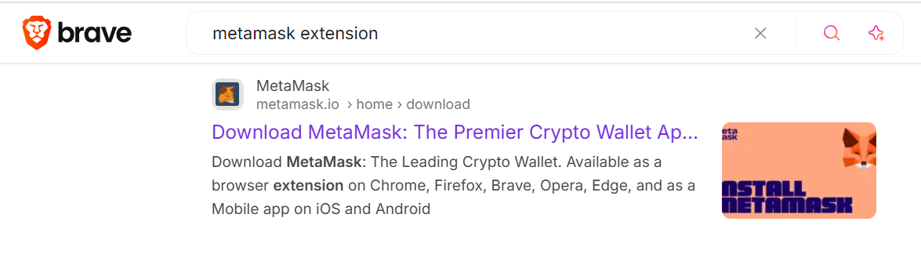
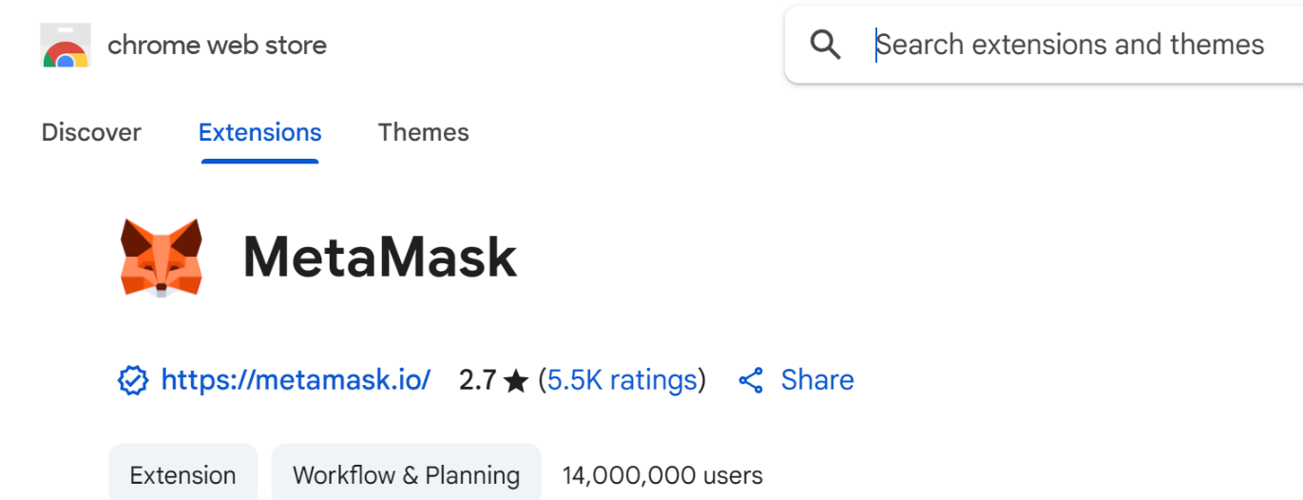

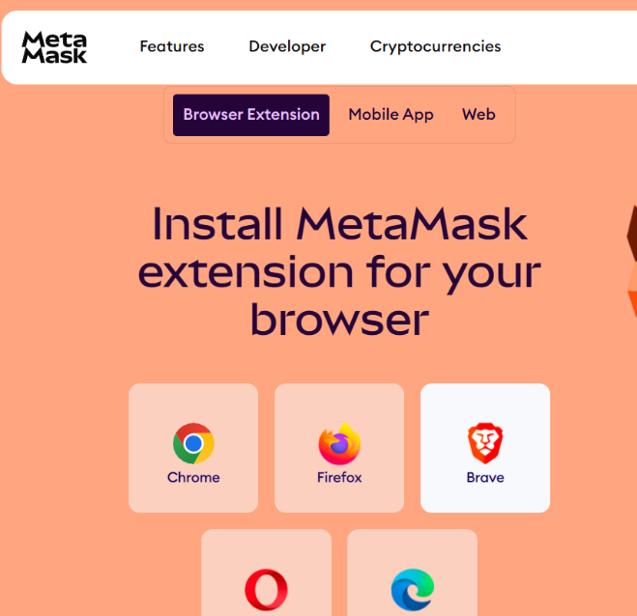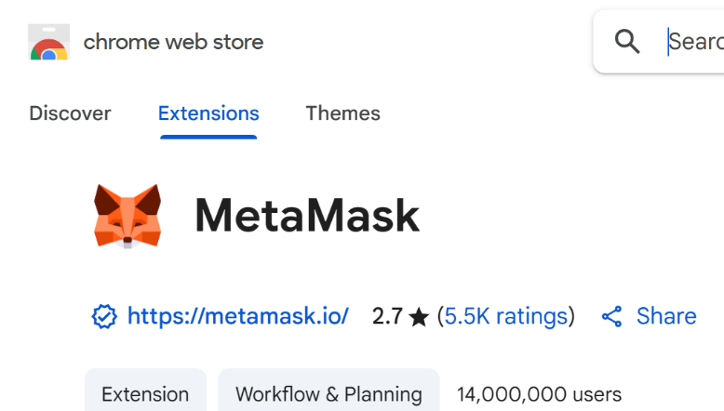

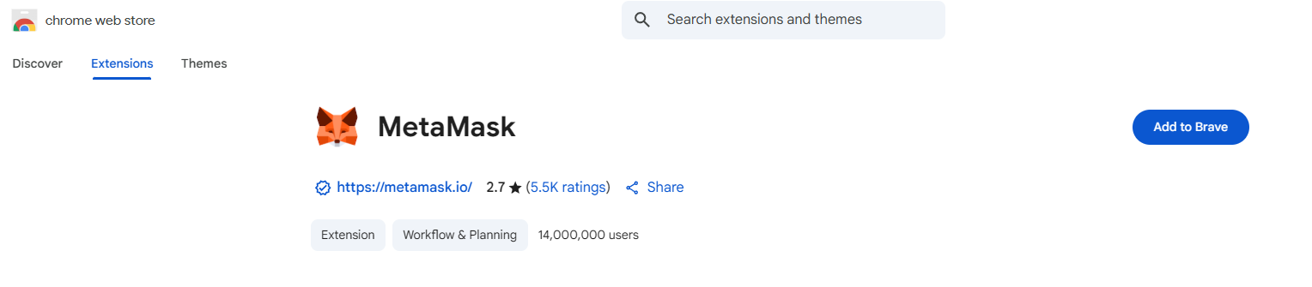

- Testing Phase: Compilation of Code (error detection)
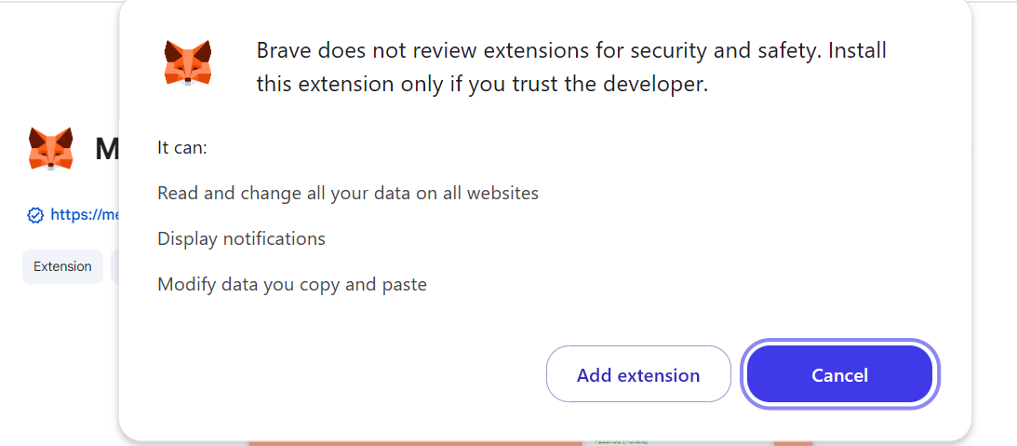

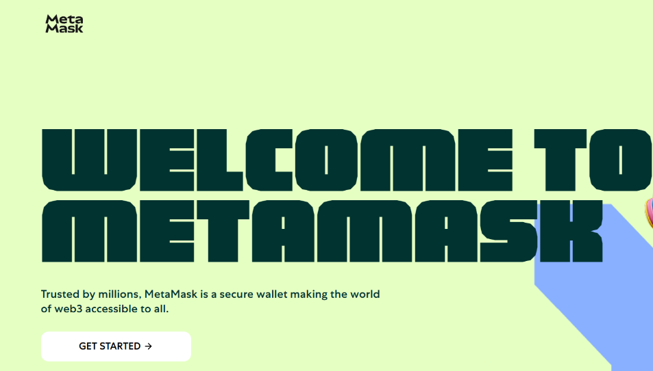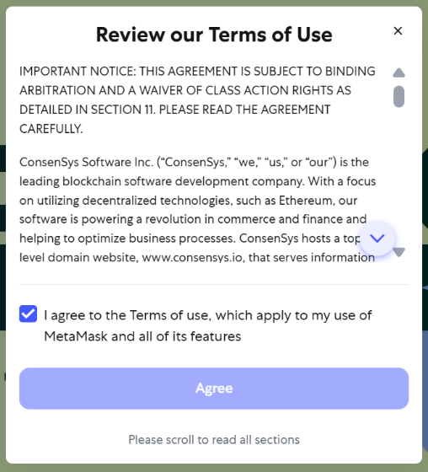

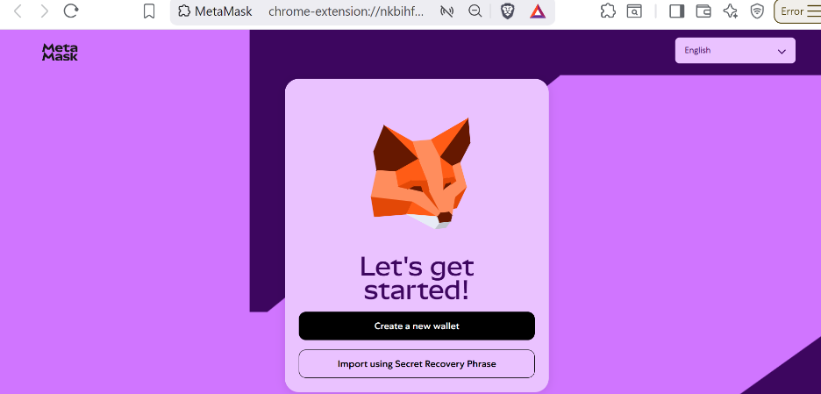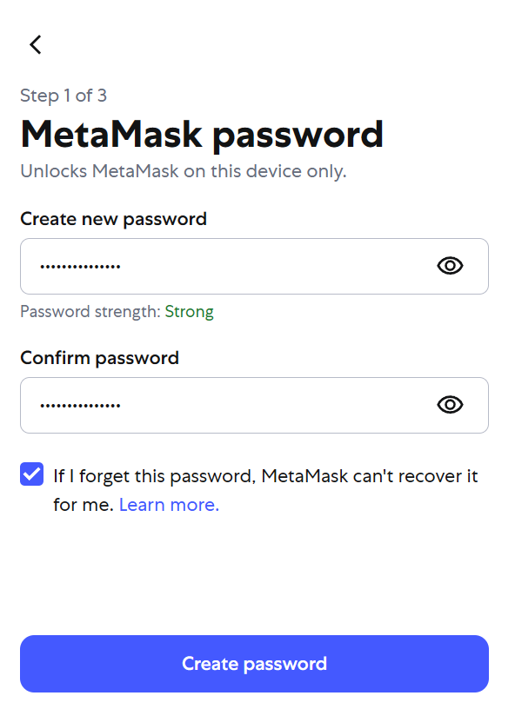

Testing Phase: detection of Code (error detection)
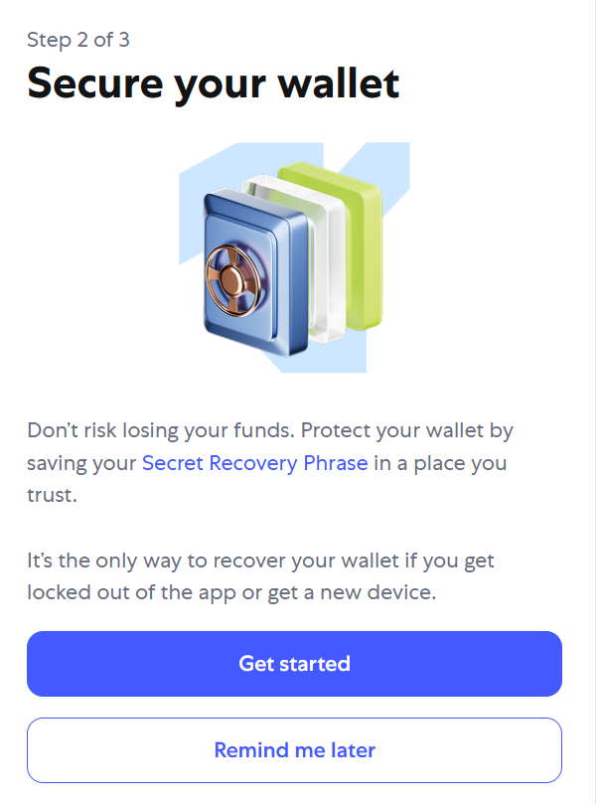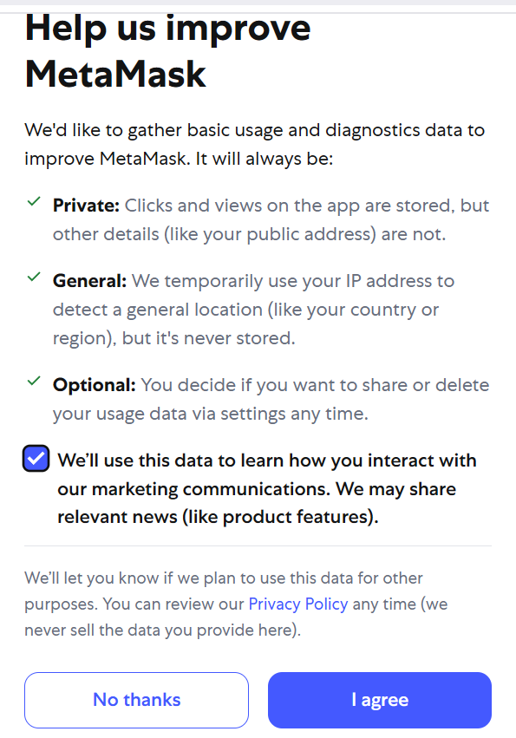

- Implementation Phase: Final Output (no error)
Applied and Action Learning

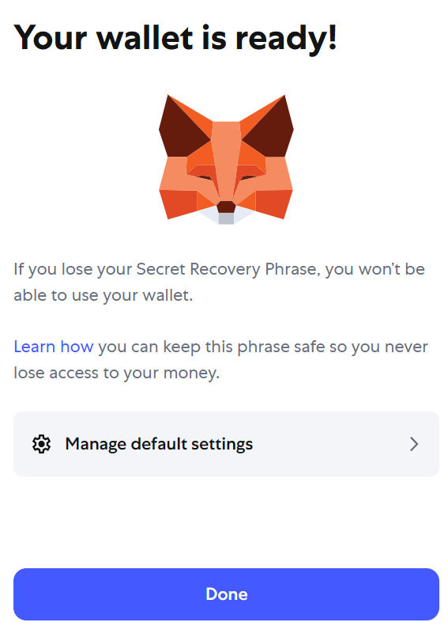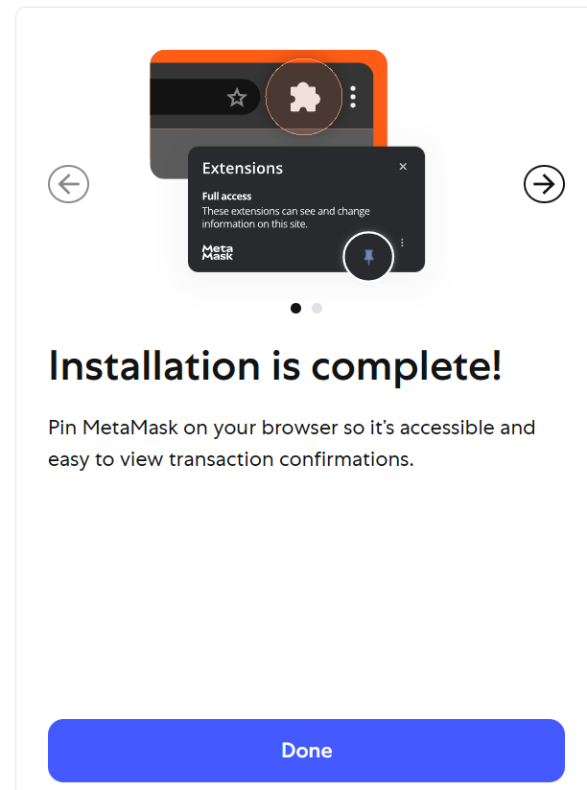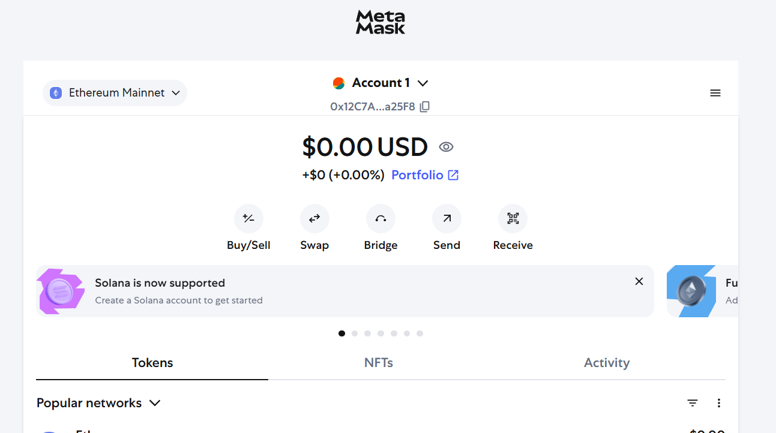

* Observations
- The seed phrase is the master key
- The presence of password protection for local device access, but that this is not a substitute for seed phrase backup.
- Each wallet has a public address (for receiving funds) and a private key (for signing transactions).
- The wallet address can be freely shared, but the private key must be kept secret.
- Wallets don’t store crypto directly; they store the keys to access blockchain assets.
- MetaMask acts as both a key manager and a transaction signer.
- Network selection determines which blockchain data the wallet shows.

ASSESMENT

Rubrics
Concept | 10
Planning and Execution/  Practical Simulation/ Programming | 10
Result and Interpretation | 10
Record of Applied and Action Learning | 10
Viva | 10
Total | 50


Signature of the Student:
Signature of the Faculty:

